Pokhara University

Level: Bachelor | Semester – Spring | Year : 2009
Programme: BE IT |  | Full Marks: 100
Course: Electronics Circuits I |  | Pass Marks: 45
 |  | Time : 3hrs.

Candidates are required to give their answers in their own words as far as practicable.
The figures in the margin indicate full marks.

Attempt all the questions.

 | - Derive the expression of the overall gain of n-stages cascaded amplifiers. Draw two Stages RC coupled amplifier.  - Calculate input impedance, output Impedance and overall voltage gain for the given BJT amplifier. Use re model. (Assume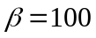). | 8  7
 | - Discuss Complementary Symmetry class B Push- Pull Amplifier. Find out power conversion efficiency.  - For the circuit given, find the value of upper cut off frequency. Assume Cbe = 10 pF, Cce = 12 pF, Cbc = 8 pF. 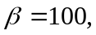fT = 800MHZ. Neglect other effects. R_{e} = 20 Ohm. | 8  7
 | - What are the main advantages of Negative feedback? An amplifier has an open loop gain of 600 and a feedback ratio of 0.5. If the open loop gain changes by 20%, find the percentage change in closed loop gain.  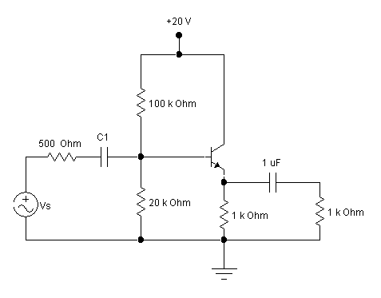  Calculate the output voltage for the BJT amplifier. "This circuit is also called emitter follower". Do you agree or disagree? Justify your answer. | 8  7
 | - List out Barkhausen Criterion for Oscillation. Describe Wein Bridge Oscillator. Draw necessary circuit diagram & derive the expression of its resonance efficiency.  - Draw LC tuned Colpitt osciallator and explain its operation. | 8  7
 | - Design an Op-amp circuit to produce following output. V₀=2V₁ +6V₂+4V₃ -12V₄ where V₁, V₂, V₃ and V₄ are inputs.  - Draw Monostabel Multivibrator circuit and explain its operation. | 8  7
 | - What do you mean by regulated power supplies? Draw Transistor series regulator circuit & explain its operation.  - Draw full wave Rectifier Circuit (center tap) and explain its operation. Derive the expression of its rms voltage. Define PIV and ripple Factor. | 8  7
 | Write short notes. (Any two)  - Darlington pair amplifier  - R-2R D/A Converter  - Falsh ADC | 2×5

